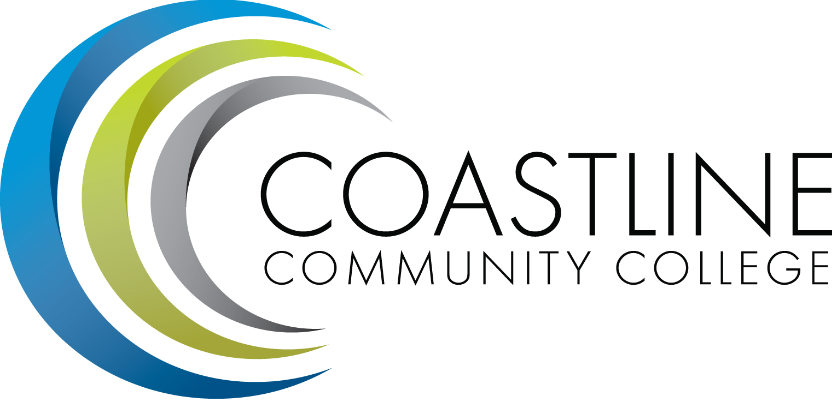
Planning, Institutional Effectiveness, and Accreditation Committee (PIEAC)
November 18, 2015
1:30 p.m. to 3:30 p.m.
Fourth Floor Conference Room

- CALL TO ORDER
  - Roll Call
  - Welcome
  - Adoption of Agenda
  - Approval of Minutes: November 4, 2015

- SPECIAL REPORTS/UPDATES
2.1Planning Guide A. Zentner

- ACTION ITEMS
3.1 Mission Statement V. Rodriguez
3.2 Part-time Financial Aid Fraud staff position R. Miyashiro

- DISCUSSION ITEMS
4.1 Size of the Committee Cheryl Stewart

- STANDING REPORTS
5.1 Accreditation V. Rodriguez
5.2 Budget Committee R. Lockwood
5.3 Program Review A. Zentner
5.4 Grants D. Aistrich
5.5 President’s Report L. Adrian
5.6 Wing Reports V. Rodriguez, C. Nguyen, R. Miyashiro
5.7 College Council V. Rodriguez
5.8 Facilities C. Nguyen
5.9 Contract Education J. Groot
5.10 Other Committees Committee

- ANNOUNCEMENTS (1-2 minutes per)

- ADJOURNMENT

